1. create table booking  
   (  
    id INTEGER not null primary key,  
    user_id INTEGER references user,  
    zone_id INTEGER references parking_zone,  
    start_time DATETIME,  
    end_time DATETIME,  
    status VARCHAR(20),  
    payment_currency VARCHAR(10),  
    payment_time DATETIME,  
    payment_amount FLOAT  
   );
2. create table marshal_shift  
   (

id INTEGER not null primary key,

marshal_id INTEGER references user,

zone_id INTEGER references parking_zone,

shift_date DATE,

check_in_time DATETIME,

location VARCHAR(255) not null,

approved BOOLEAN,

declined_reason VARCHAR(255)  
);

1. create table parking_zone  
   (  
    id INTEGER not null primary key,  
    name VARCHAR(20) unique,  
    total_spots INTEGER  
    );
2. create table user  
   (  
    id INTEGER not null primary key,  
    profile_type VARCHAR(7),  
    national_id VARCHAR(20) unique,  
    employee_id VARCHAR(20) unique,  
    first_name VARCHAR(50),  
    surname VARCHAR(50),  
    email VARCHAR(50),  
    gender VARCHAR(6),  
    phone VARCHAR(20),  
    password VARCHAR(200),  
    zone VARCHAR(20)  
   );

Login page

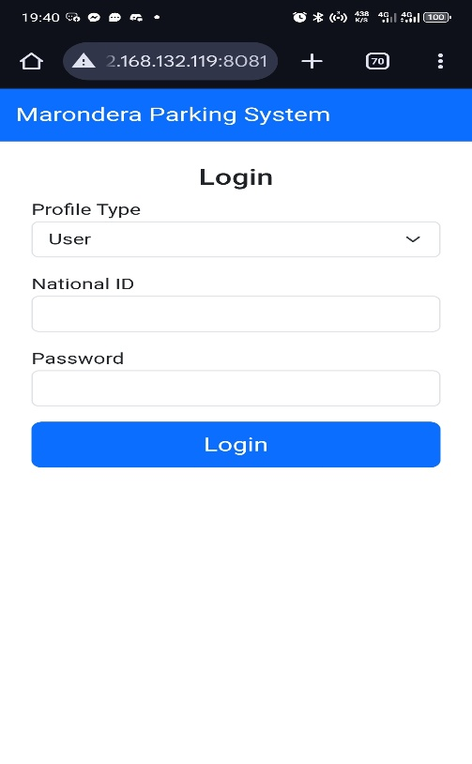

Signup

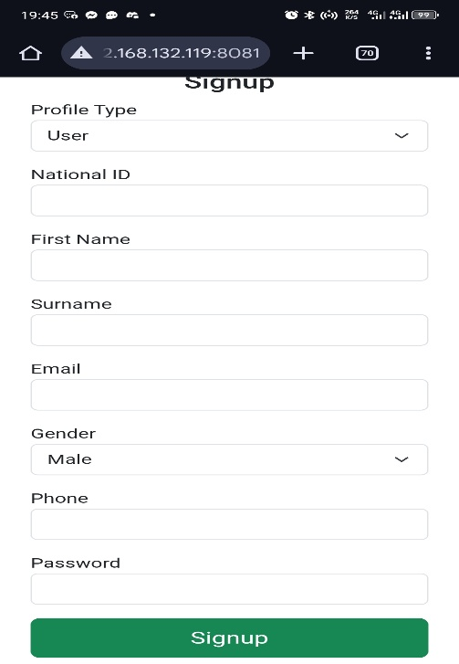

User dashboard

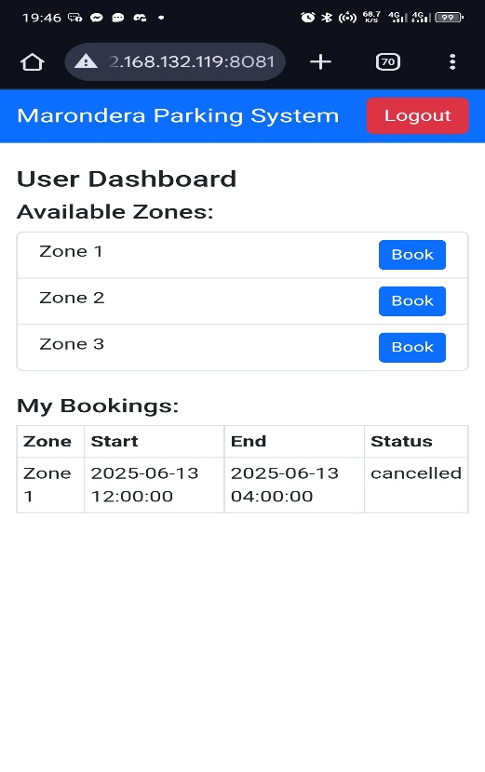

Marshal dashboard

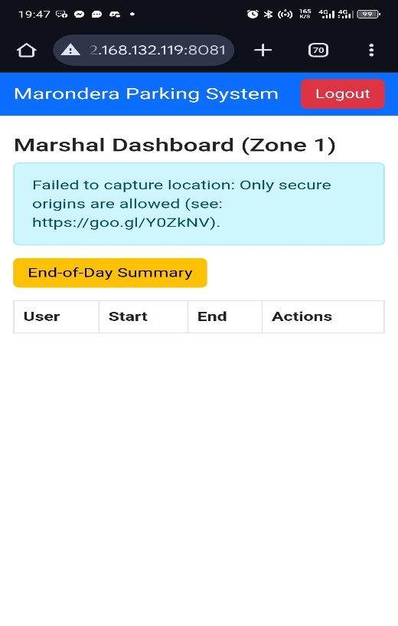

Admin dashboard

